Launching New Product : Solar Heating System
We all deserve to make your Winter Cozier at home or at work, even when the Gas Heaters or even Electric/Gas Heating Systems are in-effective; remember last winter’s Gas & Electricity scarcity. Plan now for cozier Winter that too with zero running expenditures and affordable system cost using flat bed collectors with state of art support system.
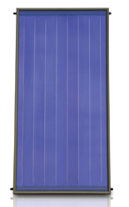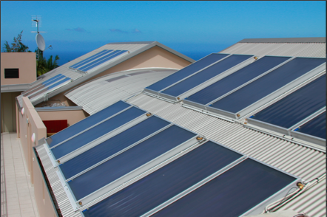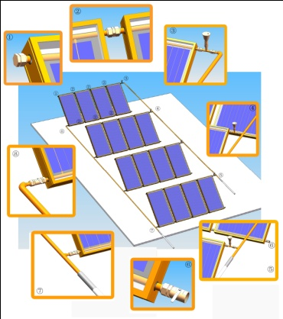
Soon you will have access to Millionsun Solar Heating Products for water as well as room heating with complete support, up gradation and indigenous designs to suit your requirements:
- Integrate your existing heating system with new Flatbed Solar Millionsun products to reduce heating cost and even operate the system when NO GAS, NO Electric Supply available.
- Install a stand alone Solar Heating System for running hot water and room heating.
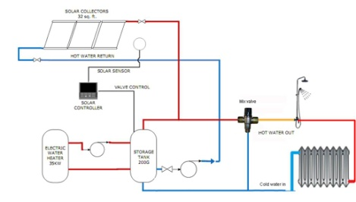
- Customized solutions at your place.
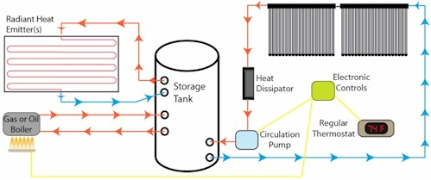

Our Services and Support
- Comprehensive Technical consultation for solutions within 24 hours
- Provision of customized system solutions
- Complete Installation and integration with building by our expert
- Complete installation guide for distant areas in the world
- Operating & Maintenance Manual and operation video
- Up gradation packages throughout system operating life
- Five years Warranty
Support , Assembly and Testing Facilities
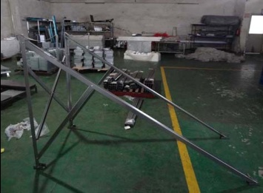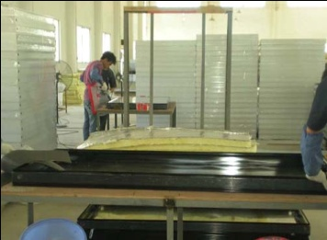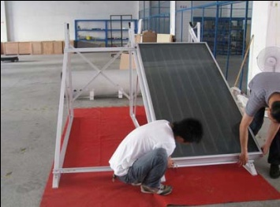
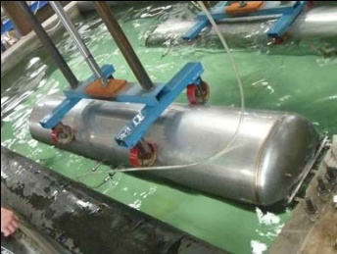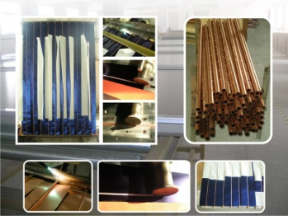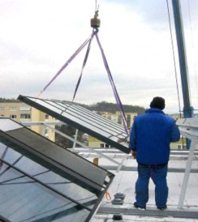

See One of the Hot selling Products : Solar Water Heater System ET-S Series
- E-TS Brochure 